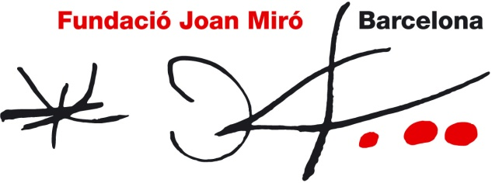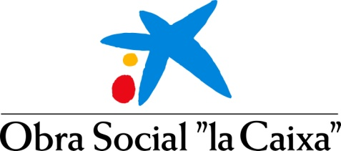

JOAN MIRÓ AWARD
NEW JURY

JURY MEMBERS

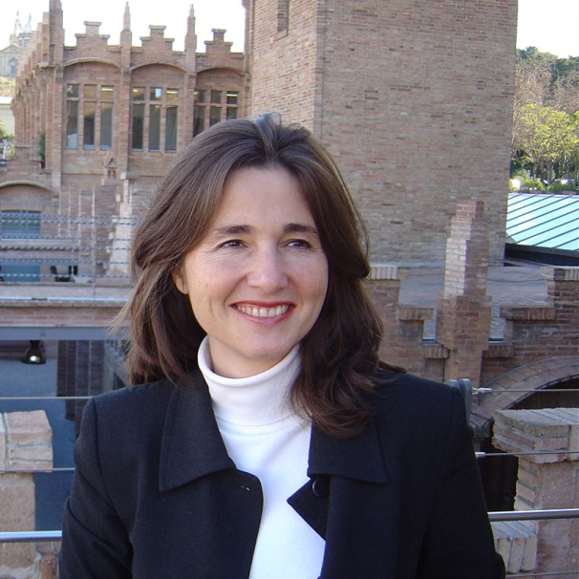 | NIMFA BISBE  Nimfa Bisbe is the director of the Fundació ”la Caixa” contemporary art collection. She holds a degree in art history from the University of Barcelona and obtained a master in art history and museology in 1990 from the University of Delaware (USA) thanks to a Fulbright/”la Caixa” scholarship.  In 1990 she joined the Fundació ”la Caixa” as head curator for the contemporary art collection and in 2002 she became the Obra Social ”la Caixa” artistic heritage director. She has endeavoured to make this heritage known as the curator of numerous contemporary art exhibitions in Spain and overseas. She has also been the curator of exhibitions and specific projects for artists including Pierre Huyghe, Omer Fast, Botto & Bruno, Jeppe Hein and Soledad Sevilla at CaixaForum Barcelona.  She is in charge of expanding the collection and, as a result, she is in constant contact with contemporary artists from around the world. She has taken part in conferences and symposiums and has also taught museology and collecting at several universities and art schools. She is a member of ICOM (the International Council of Museums), CIMAM (the International Committee of ICOM for Museums and Collections of Modern Art) and IACCCA (the International Association of Corporate Collections of Contemporary Art).

